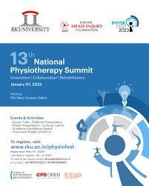

Physiofest is an Annual National Physiotherapy Summit which aims at empowering students to enhance excellence in the field of Physiotherapy. It also serves as a platform for the Students and Therapists to learn and improve their skills in the field. Physiofest brings out the innovation and research in Students and Therapists.
Shri Shamjibhai Harjibhai Talaviya Charitable (SHTC) Trust managed School of Physiotherapy, RK University (RKU) has organized the 13th National level Physiotherapy summit to provide a platform to the students to showcase their Innovative and Entrepreneurial skills.
The School of Physiotherapy constantly strives to provide quality input to students by providing them various platforms for their overall development. Taking this effort further, Physiofest is being organized by the School of Physiotherapy, RK University every year since 2009.
Taking this tradition forward we organized Physiofest 2023 on 7th January 2023 with a focus on “Innovation, Collaboration, Rehabilitation” in the field of Physiotherapy.
The event was inaugurated in presence of Executive Vice President Mr. Denish Patel. More than 350 participants from around 15 colleges attended this summit. Delegates participated in various academic activities like Platform paper presentation, Poster presentation and Innovative model making competitions.

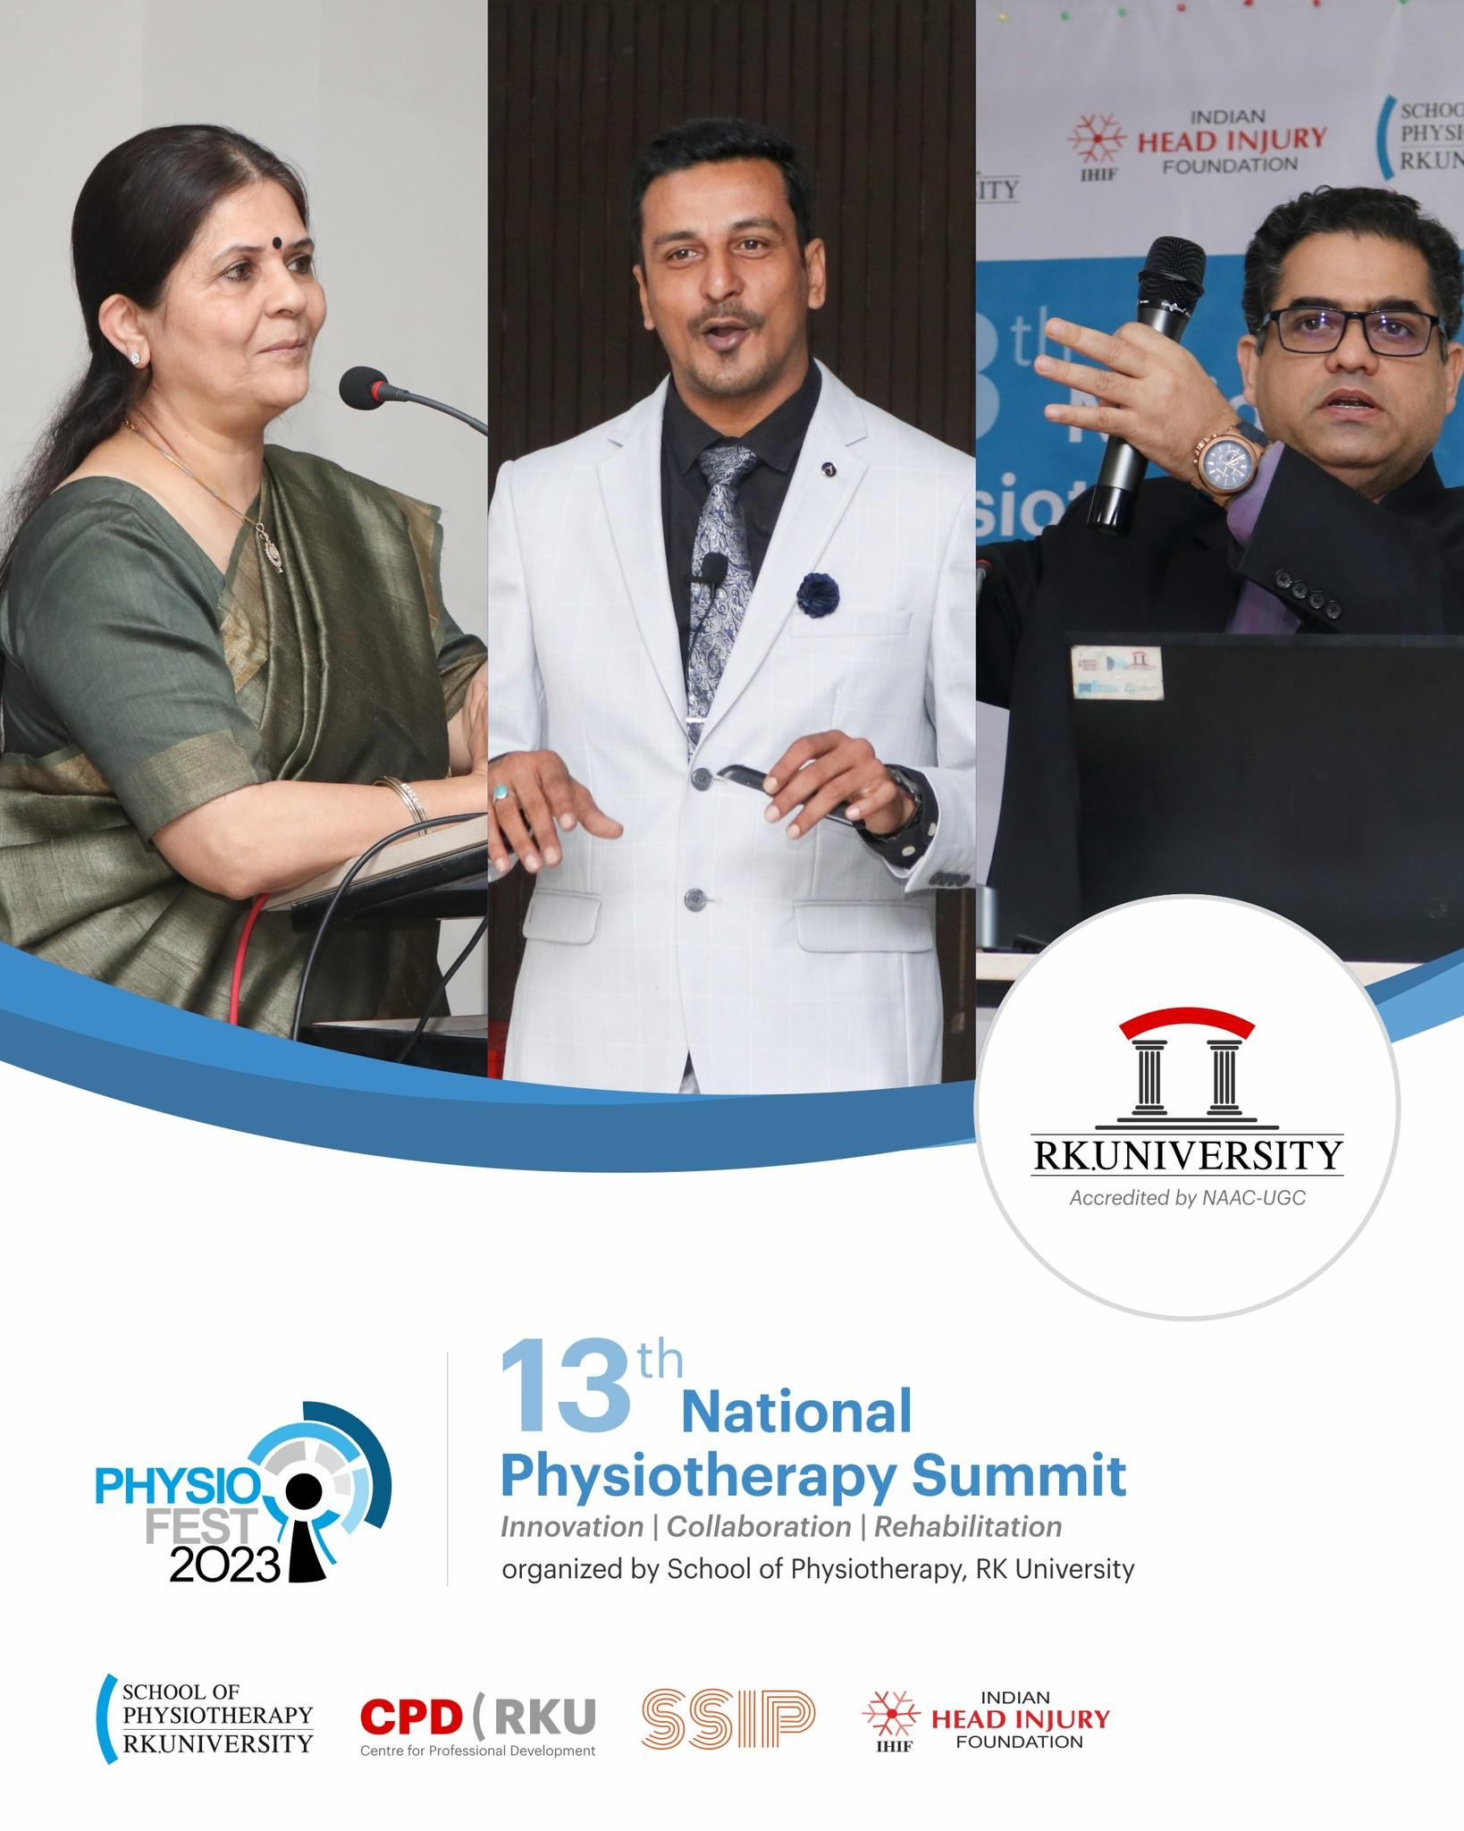

Key Speakers
Dr. Yagna Unmesh Shukla
Chief Guest/Keynote Speaker
Principal at Government Physiotherapy College, Civil Hospital, Ahmedabad.
President, Gujarat state council for physiotherapy

Waqar M. Naqvi, PhD
Directorate of Research. Nagpur, Maharashtra, India
Topic: Research Outcome based education Model (ROBEM)

Dr. Tarun Lala
Zonal Head- Physiotherapy and Rehabilitation Medicine Unit , Max superspecialty hospital, Saket and BLK-Max Hospital.
Head - Neurorehab ,Pan Max.
Hon- Rehab Advisor - IHIF ( NGO)
Topic: Recent Trend in Neuro Rehabilitation

This year we received more than 100 Theme specific Paper which were presented in the Physiofest 2023 and in addition to that we had also received around 45 theme specific Posters for the presentation.
Certificates were awarded to delegates and the selected papers are featured in ISBN approved annually published Physiotherapy newsletter Physioforum after fulfilling the publishable criteria.

